
Email Harassment Investigation
Network Traffic Analysis of Unauthorized Dormitory Wi-Fi Router

EXECUTIVE SUMMARY
This investigation was conducted after a doctor received a harassment email. The email was traced to a dormitory IP address 140.247.62.34. Network traffic captured by the university IT team using Wireshark was analyzed to identify the real sender. Due to multiple students sharing the same network, detailed traffic analysis was required.

BACKGROUND INFORMATION
The doctor received a harassment email that originated from a dormitory network. The dorm room was shared by three students: Sarah, Megan, and Olivia. The IP address involved was 140.247.62.34. An unauthorized Wi-Fi router was installed in the dorm room, and traffic from this router was captured by the university IT team. Since multiple students were using the same network, identifying the real sender required detailed analysis.

INVESTIGATION SUMMARY
The investigation involved analyzing captured PCAP files to understand how the email was sent and which IP address was involved. Multiple steps were followed to analyze TCP, TLS, and network traffic patterns to identify the attacker.

TIMELINE OF KEY EVENTS
- Harassment email received by the doctor
- Email traced to dormitory IP address
- Unauthorized Wi-Fi router identified
- Network traffic captured by IT team
- Wireshark analysis performed
- Attacker IP identified

REMEDIATION AND RECOVERY
The unauthorized Wi-Fi router should be removed from the dorm room. Network access controls should be enforced, and monitoring should be improved to prevent similar incidents in the future.

DETAILED METHODOLOGY
Wireshark was used to analyze the captured network traffic. Different protocol filters were applied to examine TCP, TLS, and other network communications related to the attacker IP address.

NETWORK TRAFFIC OVERVIEW
The dorm room network showed multiple IP addresses connected through an unauthorized Wi-Fi router. The captured traffic contained multiple TCP packets, indicating continuous communication between local and external systems.

WIRESHARK ANALYSIS APPROACH
The analysis was performed by applying protocol-based filters, examining packet details, and identifying communication patterns between local host IP 192.168.15.4 and external IP 140.247.62.34.

APPLIED FILTERS AND TECHNIQUES
Different Wireshark filters were applied, including TCP and TLS filters, to isolate traffic related to the attacker IP. These filters helped identify multiple TCP sessions and encrypted connections.

FINDINGS AND ANALYSIS
Step 1
Analysis of the dorm room network showed that multiple IP addresses were connected through the unauthorized Wi-Fi router.
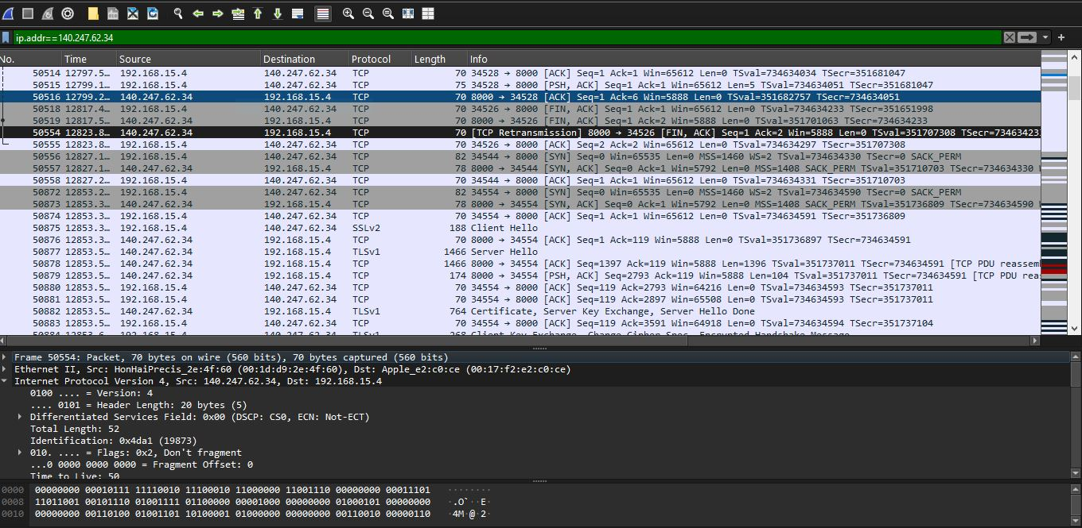
Step 2
The captured PCAP file did not observe any SMTP traffic. This confirmed that a traditional mail server was not used. TCP traffic analysis showed communication between the local host IP 192.168.15.4 and the external IP 140.247.62.34, indicating that the email was sent through a web-based email service. This confirmed that IP 140.247.62.34 was involved in the attack.
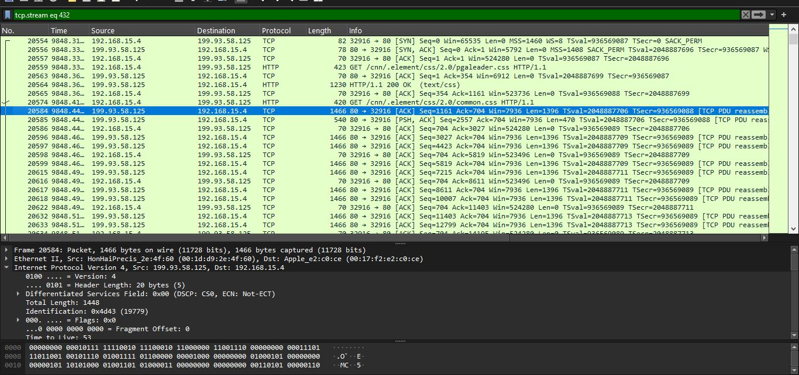
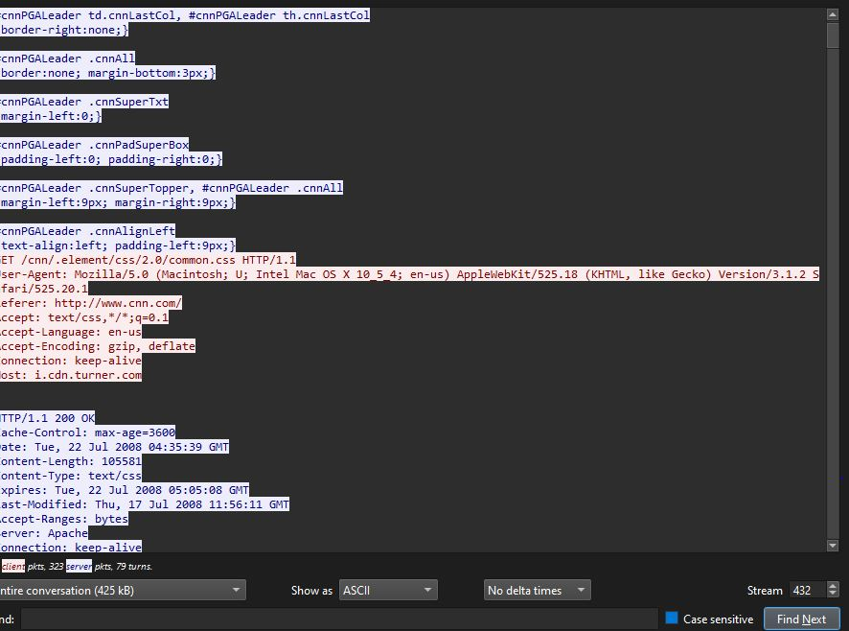
Step 3
Multiple TCP packets with different packet numbers were analyzed, indicating the presence of multiple TCP sessions. The source and destination continuously changed, showing active two-way communication rather than normal background traffic.
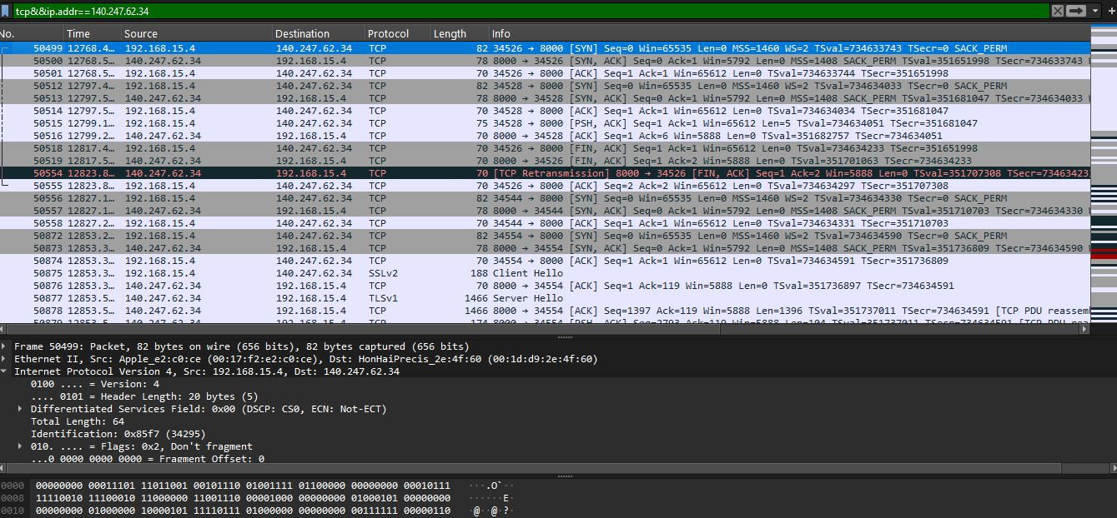
Step 4
Network traffic analysis showed that the attacker IP was not limited to basic TCP connections. By applying the TLS filter, multiple TLS-based TCP connections were identified. TLS handshake analysis revealed the Server Name Indication (SNI) field containing the remote service jabber.org, confirming that the attacker established secure web communication.
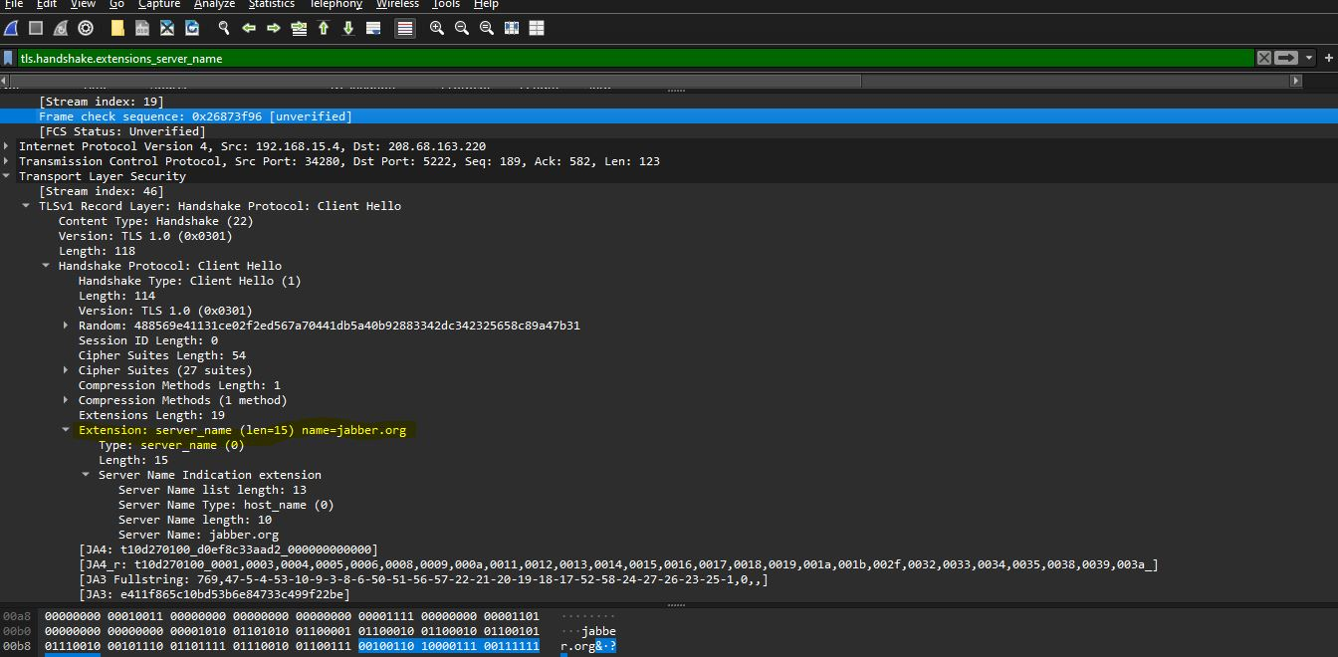

ATTACKER IDENTIFICATION
Step 5
The attacker was identified through a process of traffic correlation and elimination based on the captured PCAP file. Analysis confirmed that the suspicious activity originated from the dormitory IP address 140.247.62.34, which was actively communicating with the local host 192.168.15.4 during the time the harassment email was sent. SMTP traffic was not observed, ruling out the use of a traditional mail server and indicating that a web-based or encrypted communication method was used. Further investigation of TCP and TLS traffic revealed multiple TCP connections related to attacker IP 140.247.62.34.
One TCP connection clearly showed 140.247.62.34 as the source IP, identifying it as the origin of suspicious activity. The destination port 443 (HTTPS) indicated the use of encrypted web-based services. The TLS handshake further revealed the Server Name Indication (SNI) value “jabber.org”, supporting the conclusion that the attacker was actively using secure online services during the attack timeframe. Among the three dormitory residents Sarah, Megan, and Olivia only Sarah was active online during the relevant period, while the others were excluded based on traffic correlation and activity elimination provided in the task scenario. Therefore, based on IP address association, multiple TCP/TLS connections, and encrypted HTTPS communication evidence, Sarah is identified as the attacker responsible for sending the harassment email.

CONCLUSION
The investigation confirmed that the harassment email originated from the dormitory network using a web-based and encrypted communication method. Although SMTP traffic was not observed, TCP and TLS analysis successfully identified IP address 140.247.62.34 as the attacker. Multiple TCP and TLS connections indicated continuous attacker activity during the incident.

